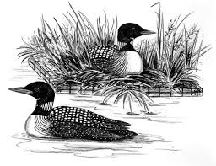
Thank you for
helping last year
to purchase
updated buoys,
markings and new
nests for the loons. Please consider increasing your total donation this year to fight our closest invader, Starry Stonewort, in nearby Lake Koronis and Grand Lake!

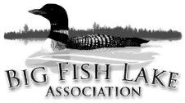
Big Fish Lake Association
27715 Hidden Cove Rd
Cold Spring, MN 56320
www.bigfish.mnlakesandrivers.org
2018 Membership Dues
(For January 1 – December 31, 2018)

To:

Your 2016 donation was: $ Your 2017 Donation was: $

Please consider increasing your 2018 donation to help us protect our lake from AIS!
$60.00 | Level 1 – Loon Lover’s Basic Membership
Help cover the association’s operational costs.

$75.00 | Level 2 – Eurasian Milfoil Evaders
100% participation at this level will provide for minimal boat inspections.

$100.00 | Level 3 – Starry Stonewort Haters
This is the amount necessary (at 100% participation) to perform boat inspections for 3 months,
EVERY DAY, beginning on the Fishing Opener in May to August 15, 2018.

$250.00 | Level 4 – AIS Combatants (new timeline to go from 5 to 6 months!)
At 100% participation we would be able to perform boat inspections for 6 months, EVERY DAY,
beginning at the opening of the crappie season in the beginning of May through October, 2018.

$500.00+ | Level 5 – Sunset Cruisers
Help ensure Big Fish Lake as a pristine natural resource for us and future generations.

Please write check to: Big Fish Lake Association or BFLA
Property Address:
 | On File | Enter New/Updated Information
E-mail:
Tel:

Membership Dues | Add’l Inspections | Total Donation
$_________ | $_________ | $_________
Comments or Suggestions:

Your payment of dues and donation are tax deductible to the extent allowed by law. No goods or services will be provided in exchange for your dues and donation.

Please return this updated portion with your payment by December 31, 2017.

