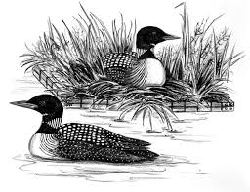
Thank you for
helping last year
to add more boat
inspections to fight
AIS. Now we need
your help to increase the funding to continue doing third party surveys to check our lake regularly for Starry Stonewort (also known as the
“lake killer”) and Eurasian Milfoil. Also, we will need to continuously observe the zebra mussel population.

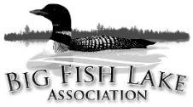
Big Fish Lake Association
27715 Hidden Cove Rd
Cold Spring, MN 56320
www.bigfish.mnlakesandrivers.org

2020 Membership Dues
(For January 1 – December 31, 2020)

To: Name
Address
City, State, Zip

Your 2018 donation was: $ Your 2019 Donation was: $

Please consider increasing your 2020 donation to help us protect our lake from more AIS!
$60.00 | Level 1 – Loon Lover’s Basic Membership
Help cover the association’s operational costs.

$75.00 | Level 2 – Eurasian Milfoil Evaders
100% participation at this level will provide for minimal boat inspections.

$100.00 | Level 3 – Starry Stonewort Haters
This is the amount necessary (at 100% participation) to perform boat inspections for 3 months,
EVERY DAY, beginning on the Fishing Opener in May to August 15, 2020.

$250.00 | Level 4 – AIS Combatants (new timeline to go from 5 to 6 months!)
At 100% participation we would be able to perform boat inspections for 6 months, EVERY DAY,
beginning at the opening of the crappie season in the beginning of May through October, 2020.

$500.00+ | Level 5 – Sunset Cruisers
Help ensure Big Fish Lake as a pristine natural resource for us and future generations.

Please write check to: Big Fish Lake Association or BFLA Please send in by April 15, 2020
Property Owner:
Property Address:
 | On File | Enter New/Updated Information
E-mail:
Tel:

Membership Dues | Add’l Research | Total Donation
$_________ | $__________ | $_____________
Comments or Suggestions:

Your payment of dues and donation are tax deductible to the extent allowed by law. No goods or services will be provided in exchange for your dues and donation.

